A chess knight can move as indicated in the chess diagram below:

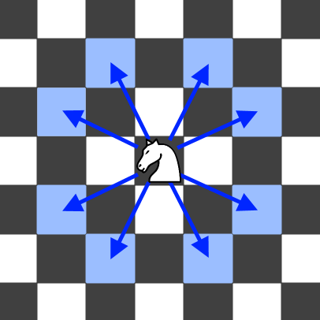 .           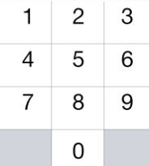

This time, we place our chess knight on any numbered key of a phone pad (indicated above), and the knight makes N-1 hops.  Each hop must be from one key to another numbered key.

Each time it lands on a key (including the initial placement of the knight), it presses the number of that key, pressing N digits total.

How many distinct numbers can you dial in this manner?

Since the answer may be large, **output the answer modulo 10^9 + 7**.

**Example 1:**

**Input:** 1

**Output:** 10

**Example 2:**

**Input:** 2

**Output:** 20

**Example 3:**

**Input:** 3

**Output:** 46

**Note:**

* 1 <= N <= 5000